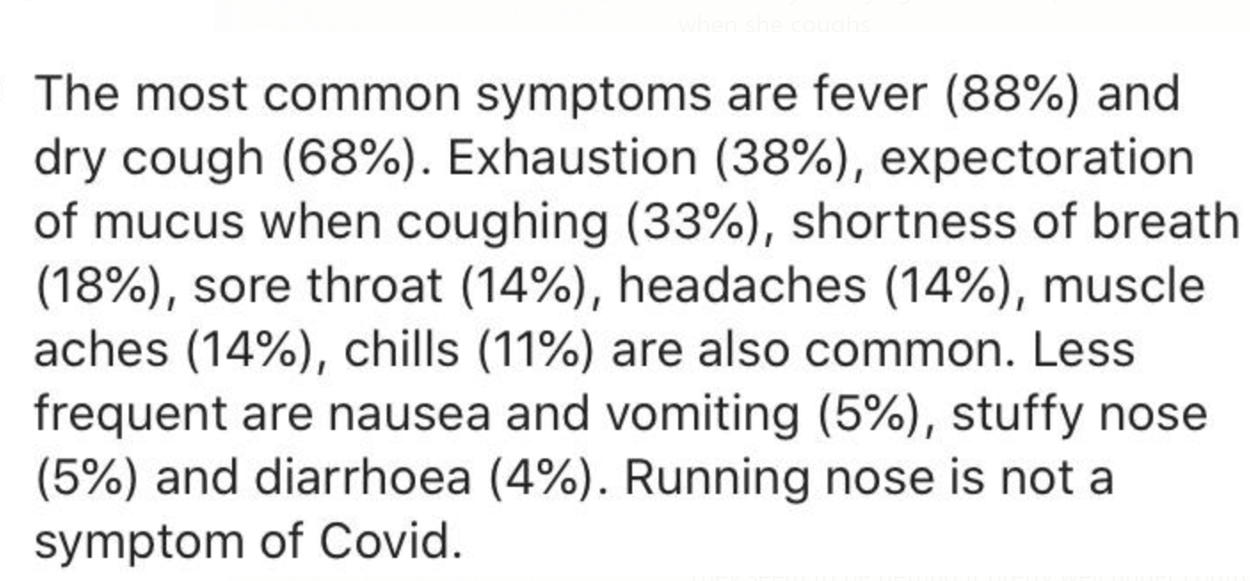

1. Do you have a fever? Y/N .88
2. Do you have a dry cough? Y/N .38
3. Are you coughing up phlegm or mucous? Y/N .33
4. Do you have shortness of breath? Y/N .18
5. Can you hold your breath for 10 seconds? Y/N .33
6. Are you feeling fatigued or exhausted? Y/N .38
7. Have you got a sore throat? Y/N .14
8. Are you experiencing headaches? Y/N .14
9. Are you experiencing muscle aches? Y/N .14
10. Are you experiencing chills? Y/N .11
11. Have you got nausea/ have you been vomiting? Y/N .05
12. Have you had diarrhoea? Y/N .05
13. Do you have a stuffy nose? Y/N .04
14. Do you have a runny nose? Y/N -1
15. Have you been to an affected area in the past two weeks e.g. Spain, Italy, Wuhan? Y/N .3
16. Have you been in contact with any people who have tested positive for the virus? Y/N .5
17. Have you been to a hospital in the past two weeks? Y/N .3